STOCK MARKET PREDICTION USING MULTI-SOURCE MULTIPLE INSTANCE LEARNING
Conclusion, Future Scope and References
Department of Computer Science and Engineering, [COLLEGE NAME]
Batch C4 (CSE-C) · Academic year [ACADEMIC YEAR]
Table 1: Project team
S.No. | Student name | Roll number
1 | Pottepaka Lingaswamy | 23K91A05J7
2 | Maduna Naveen Kumar | 23K91A05D7
3 | Meedigeri Keerthi | 24K95A0517
4 | Mareddy Sai Karthik | 23K91A05E8

Project guide: K Anusha
Chapter and section numbers quoted in the text (for example Chapter 8 or Section 6.2) refer to the full project report, 17.Final Document. Figures and tables in this document are numbered from 1.

1. CONCLUSION

1.1 Summary of the work
The project set out to predict stock direction from prices, news and social media with multiple instance learning. It delivered QuantPulse, a working forecasting product that implements the base paper's hybrid pipeline [1]: ten tickers, five classical baselines, four deep-model tiers (LSTM, attention, sentiment, simulated FedAvg), 5- and 30-day forecasts with bands, a FastAPI backend and a six-screen React website, with 56 passing tests and 26 passing smoke checks. In the documentation phase the product was evaluated far more strictly than the base paper evaluates its own: five seeds, a persistence baseline, scoring against real closes, and a forward test against the closes that followed the stored forecasts. Because the title asks for multiple instance learning and the product has none, an offline MIL study was added on 46,532 real FNSPID headlines.
The work therefore has two layers. The first is the product layer: what a user sees and can run, which behaves as the base paper's design says it should and is robust against bad input (invalid symbols return 400, unknown ones 404, missing artefacts 503). The second is the evidence layer: what the numbers say about the forecasts, which is mostly negative. Keeping the two apart is the main discipline of this report, and the same split is used in every chapter: Chapter 6 and Chapter 5 describe what was built, Chapter 7 and Chapter 8 describe what was measured.

1.2 Objectives achieved and not achieved
Table 2: Batch objectives against the outcome
Objective | Status | Evidence
1. Collect prices, financial news and social-media text | Partly | Prices yes (Yahoo Finance, 10 tickers). News only as NewsAPI headlines when a key is set; the shipped run used a synthetic fallback. No social-media source.
2. Align the data into daily instances per trading day | Partly | Daily alignment yes, but headlines are reduced to one mean score per day; the offline study builds true bags of headlines.
3. Represent each day as a bag (MIL) | Offline only | Not in the product. The offline study bags 46,532 real headlines and trains mean, max and gated-attention pooling.
4. Hybrid of sequence learning on prices and attention over news | Partly | LSTM + attention over the 20-day price window + a daily sentiment channel (product); attention over news instances only in the offline study.
5. Predict direction; accuracy, precision, recall, F1 | Offline only | The product reports MAE/R2 and a direction figure; precision, recall and F1 are computed only in the offline study.
6. Compare multi-source against a price-only baseline | Done, no gain | Offline: best MIL variant +2.1 points [-0.9, +5.2] over the price-only LSTM; the product's own ablation is not valid because its sentiment is synthetic and zero in training.

Two of the six objectives are met only partly by the product and two only by work done outside it; none is claimed beyond what the table says.
The statuses are deliberately strict. 'Partly' means that the product contains a simpler version of the step; 'Offline only' means that the step exists as a script that is not part of the application; 'Done, no gain' means the comparison was made and showed no improvement.

1.3 Key findings
1. No deep tier beats persistence. Against the real closes the best tier (LSTM plus attention) has a mean absolute error of $29.37 ± 1.39 over five seeds, and persistence $6.24; R2 is -3.5. Random Forest is the best of the shipped models on 6 of 10 tickers.
2. The shipped scoring is optimistic. Test targets are clipped to the training range, which affects 5 of 10 tickers strongly; directional accuracy reads 68.3 % in the product and 53.0 % against real closes.
3. The stored forecasts failed a forward test. From 2026-09-08 the 5-day forecasts averaged -14.8 % while prices moved -0.4 %; the 5-day MAE was $59.04 against $11.09 for no change, and the trend flag was right for 4 of 10 (30-day: 6 of 10).
4. Sentiment and federation did not help. The sentiment channel is zero during training, so the tier is unstable (MAE $37.55 ± 7.69); a time-shuffled placebo scores $29.09, the same as no sentiment; FedAvg scores $43.70 ± 11.14.
5. Real news bags gave no measurable gain in the offline study. On 1,309 pooled test samples the always-up rate is 53.6 %; the matched price-only LSTM reaches 48.8 %, the gated-attention MIL model 49.8 % (F1 0.42), and a placebo with other days' bags 49.8 %. The largest paired gain over price-only is +2.1 points with a 95 % interval [-0.9, +5.2].
6. The attention weights did not single out headlines. In the 8 test days inspected the highest weight was on average 1.15 times the uniform weight 1/n; for example on MSFT 2023-10-27 (24 headlines) the top three weights were 0.051/0.049/0.047 against a uniform 0.042, and the predicted probability was 0.50, so gated attention behaved almost like mean pooling.
7. The base paper's R2 of 0.91 was not reproduced. Shipped R2 averages -67.7 for the hybrid; datasets and protocols differ (30-day window and scaled units in the paper, two years and dollars here), so this is not a refutation.
Reading the MIL table needs care. Accuracy alone is dominated by the class balance: the test samples are 53.6 % up days, and the price-only LSTM trained on all history since 2016 reaches 53.6 % accuracy only because it predicts 'up' for 95 % of days (recall 0.96, ROC-AUC 0.49, i.e. no ranking skill). The matched-window models lean the other way and call fewer days up, which lowers recall and F1. ROC-AUC, which does not depend on a threshold, sits between 0.497 and 0.524 for every price or price-plus-news model, which is within chance for a sample of this size. Restricting the score to days that have at least one headline (94 % of test days) changes nothing: the MIL attention model scores 49.7 % on those days. The news-only MIL model, which has no price input, reaches 51.4 % accuracy but with ROC-AUC 0.49: it, too, mostly predicts the majority class.
Table 3: Headline measurements behind the findings
Measurement | Value | Source
Persistence MAE (yesterday's close), 10-ticker mean | $6.24 | 5-seed re-run, true closes
LSTM + attention MAE / R2 on real closes | $29.37 / -3.5 | 5-seed re-run
LSTM MAE / sentiment tier MAE / FedAvg hybrid MAE | $53.71 / $37.55 / $43.70 | 5-seed re-run
Shipped direction vs true direction (LSTM + attention) | 68.3 % vs 53.0 % | 5-seed re-run
Stored 5-day forecast: mean change vs actual | -14.8 % vs -0.4 % | Forward test, 10 tickers
Stored 30-day forecast: mean change vs actual | -8.1 % vs +0.8 % | Forward test, 10 tickers
MIL study: always-up / price-only LSTM / MIL attention accuracy | 53.6 % / 48.8 % / 49.8 % | 1,309 test samples
Warm API latency, stored forecast / history / sentiment (median) | 11 ms / 139 ms / 4.6 s | measure_api.py
Automated checks | 56 pytest + 26 smoke, all passing | docs/metrics

1.4 Lessons learned
• Add the naive baseline first. Every deep tier looks reasonable on a chart because a price series is smooth; only the comparison with 'tomorrow equals today' shows that none of them forecasts anything useful at the level of dollars.
• Check what the evaluation function does to the data. One np.clip in the scaler step changed both the error and the direction figures for most tickers; the same predictions score 68 % or 53 % depending on whether the target is clipped.
• An ablation needs a working channel. A sentiment input that is zero during training cannot be shown to help or hurt; the placebo made that visible.
• Test the way the product will be used. The stored forecasts look plausible on the screen until the realised closes are drawn next to them, as the Forecast screen now does.
• State what is synthetic and what is missing. The shipped sentiment is template text, the product has no MIL and no social media; the documents say so rather than let the title imply otherwise.
QuantPulse is a research and education tool. It is useful for teaching the pipeline from price download to forecast screen, for demonstrating how an ablation is built, and as a test bed for evaluation mistakes (clipping, empty channels, missing baselines) that the documents expose. It is not suitable for trading decisions, and every screen states that forecasts are statistical estimates, not financial advice.
A reader should take three things from the findings. First, the numbers that the application displays are not the numbers that a careful evaluation produces, and the difference is large enough to change the story. Second, the multi-source idea in the title is untested by the product and, in the offline study, unsupported at the sample size available. Third, none of this makes the engineering worthless: a clean, tested pipeline with honest diagnostics is exactly what is needed before a better model is attempted.

1.5 Known limitations
The sentiment source is synthetic in the shipped run, the product has no multiple instance learning, social-media text or precision/recall/F1, the data are short (501 rows, 97 test windows per ticker), the federation is simulated, and the multiple-instance study covers seven tickers over two years. Chapter 8 and the Scope and Limitations document list each limit with its evidence.
The results behind the key findings are shown below: how the deep tiers compare with simply repeating yesterday's close once they are scored against the real closes, and how the measured results sit next to the figures reported in the base paper (different data and protocols, so indicative only).
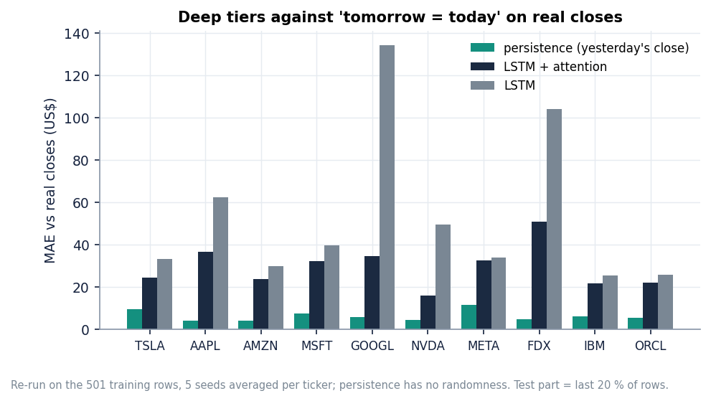
Figure 1: Mean absolute error of LSTM + attention (five seeds, real closes) and of the persistence baseline for each ticker.
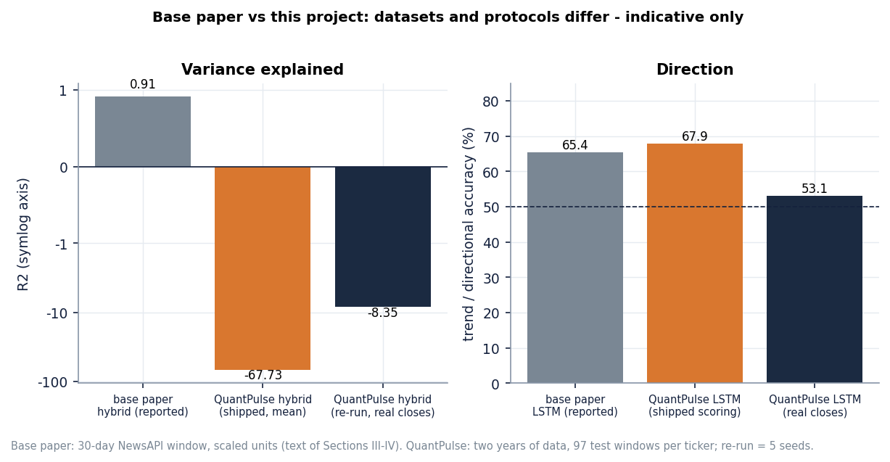
Figure 2: Figures reported in the base paper next to those measured here: datasets and protocols differ, indicative only.

2. FUTURE SCOPE

2.1 Improvements to the existing system
1. Score against the real closes. Remove the clip from test targets, or fit scalers on a range that includes the test period's growth, and report persistence next to every model; this alone changes the direction figures from 68 % to about 53 %.
2. Predict returns, not levels. A target of next-day log return (or direction) is stationary, does not need level scaling and cannot be clipped away; levels follow by compounding.
3. Fill the sentiment channel for the whole history. Fetch archived headlines (the FNSPID news used in the offline study, or a paid archive) so the channel is non-zero in training, and drop the synthetic fallback from the ablation.
4. Walk-forward validation. Replace the single 80/20 split by rolling or expanding windows with many test periods, and report mean and spread, as the offline study already does for direction.
5. Refresh and retrain. Write the training date into the artefact, retrain on a schedule, and have the Forecast screen compare the stored forecast with the realised closes automatically (the screen already shows a banner and the miss columns).
6. Honest uncertainty. Use residuals from walk-forward folds to build prediction intervals, or conformal intervals, instead of a sqrt(h) band built from one-step residuals.
These six changes are small relative to the model work and each addresses a measured defect. Together they would turn the product's evaluation from a demonstration of the base paper's recipe into a test of whether that recipe has any predictive value on current data.

2.2 Additional features
• A multiple-instance model in the product. Promote scripts/mil_study.py into backend/app/: embed each day's headlines, pool them with gated attention, and show which headlines received the most weight on the Sentiment screen.
• A direction classifier with precision, recall and F1. Add a classification head and report a confusion matrix per ticker, with a probability threshold the user can move.
• A social-media source. Add a licensed or public discussion feed as a second bag per day, so that the multi-source claim is true; keep it optional behind a key.
• A baseline panel. Show persistence and drift on every forecast chart so a user can see at a glance whether a model adds anything.
• More inputs. Technical indicators (moving averages, as in the base paper), volume features, sector indices and macro-economic series.
Each feature should be added behind a flag and scored with the same five-seed, true-target, persistence-relative protocol used in this report, so that a new component is kept only if it beats the baseline by clearly more than the seed-to-seed spread. Across the five seeds the standard deviation of the true-target MAE was about $1.1 for the LSTM and $1.4 for LSTM plus attention, but $7.7 for the sentiment tier and $11.1 for the federated tier, so a difference of a few dollars between two single runs of the unstable tiers means nothing.

2.2.1 How much data the next study needs
The standard error of an accuracy figure measured on n samples near 50 % is about sqrt(0.25 / n). With the 1,309 test samples of the offline study it is 1.4 accuracy points, so a 95 % interval is about +-2.7 points wide, which is the reason the observed gaps of one to two points cannot be told from zero. To detect a real gain of one point the standard error must fall to about 0.5 points, which needs on the order of 10,000 independent test samples; that means more tickers (several hundred rather than seven) and several years of dense headlines, not just more seeds, because seeds repeat the same test days.

2.3 Scalability and deployment
The API is stateless apart from its JSON files, so it scales horizontally behind a reverse proxy once a database or object store replaces the files. Stored forecasts already answer in about 11 ms; the two slow routes are the history download (139 ms median, it calls Yahoo Finance on every request) and the sentiment route (about 4.6 s median, FinBERT inference). Both should move to a scheduled job and a cache. A real deployment also needs authentication, rate limits, a database for prices, headlines and forecasts, a model registry, monitoring of forecast error against realised prices, and a container image (the Dockerfile exists but was not exercised here).
The offline MIL script is a reasonable starting point for the product version: it already builds bags with a no-look-ahead time rule, embeds headlines with FinBERT-tone, pools them with mean, max or gated attention, and reports accuracy, precision, recall and F1 with paired bootstrap intervals. What it lacks is a serving path (embedding a day's headlines on request), an instance-relevance filter and a store for the headline archive.

2.4 Further research
• Real federated learning. Run clients in separate processes or machines, normalise scales across clients, and measure communication cost, drop-out and what federation does to accuracy, since the simulated version made the forecasts worse.
• Longer news history and more tickers. The offline study covers seven tickers in 2022-2023; repeating it with a denser archive and many more tickers would give the statistical power that 1,309 test samples lack.
• Better MIL formulations. Instance-level relevance to the ticker (many headlines mention several companies), transformer instance encoders, and bag-level losses that cope with empty bags.
• Explanation and trust. Attention weights over headlines, calibration of direction probabilities and a comparison with a purely statistical benchmark for every claim.
• Market microstructure and regime effects. Test whether any news effect appears at an intraday horizon, where daily stamps and close-to-close labels hide it; the base paper itself lists larger-scale sentiment datasets and real-world federation as future work [1].

2.5 A suggested order of work
Table 4: Roadmap
Step | Change | Why first | Effort
1 | Persistence baseline and true-target scoring in backend/train.py and the Models screen | Removes the main overstatement; a few lines of code | Small
2 | Train on returns or direction; walk-forward folds | Makes the evaluation honest and the target stationary | Medium
3 | Archived headlines for the full history; drop the synthetic fallback from the ablation | Gives the sentiment tier a chance to learn | Medium
4 | Promote the MIL model into the backend with a classifier head and a P/R/F1 panel | Meets objectives 3 and 5 inside the product | Medium
5 | Social-media feed as a second bag | Meets the multi-source claim | Medium to large
6 | Scheduled retraining, forecast-vs-actual tracking, database, authentication | Production readiness | Large
7 | Real federated clients | Tests whether federation helps at all | Large

Steps 1 to 3 are cheap and decide whether the later steps are worth taking: if returns remain unpredictable once the evaluation is honest, the MIL and federation work should be judged as research questions, not as product features.
A final research question concerns the evaluation itself. A daily direction label is noisy: a one-cent move counts as 'up'. Labels that ignore moves smaller than a cost-aware threshold, or that use the sign of an excess return over a market index, would remove most of the coin-flip component and make any real signal easier to detect. The offline study's pooled up-day share of 53.6 % shows how close to a coin flip the plain label is.
None of these steps should be taken without first adding the persistence baseline and true-target scoring; both are cheap and would have prevented the main overstatements found here.

3. REFERENCES
[1] Y. Nejatbakhsh and M. Aliasgari, "Enhancing stock market prediction with hybrid deep learning: Integrating LSTM, transformer attention, federated learning, and sentiment analysis," IEEE Access, vol. 14, pp. 3926-3942, 2026, doi: 10.1109/ACCESS.2025.3649668.
[2] "A hybrid artificial intelligence model for stock market prediction using financial news, social media sentiment, and corporate performance indicators," Revista Electronica de Veterinaria, vol. 25, no. 1, 2024 (as listed in the batch literature survey; authors not available in Crossref).
[3] G. Officioso, G. Sperli and A. Vignali, "Financial news sentiment meets market data: A large language model-based approach to stock price prediction," Inf. Sci., vol. 754, Art. no. 123711, Oct. 2026, doi: 10.1016/j.ins.2026.123711.
[4] H. Chang, "Multimodal stock price prediction in the Chinese market via financial sentiment analysis and feature fusion," in Proc. 3rd Int. Conf. Data Anal. Mach. Learn., SCITEPRESS, 2025, pp. 211-216, doi: 10.5220/0014761600004818.
[5] P. Xiao, "Stock market prediction based on financial news, text data mining, and investor sentiment analysis," Int. J. Inf. Syst. Model. Des., vol. 15, no. 1, pp. 1-13, 2024, doi: 10.4018/ijismd.361593.
[6] X. Zhang, S. Qu, J. Huang, B. Fang and P. Yu, "Stock market prediction via multi-source multiple instance learning," IEEE Access, vol. 6, pp. 50720-50728, 2018, doi: 10.1109/ACCESS.2018.2869735.
[7] P.-J. Liao, H.-S. Lee, Y.-F. Cheng, L.-W. Chen, H.-y. Lee and H.-M. Wang, "Generalized stock price prediction for multiple stocks combined with news fusion," arXiv:2603.19286, Mar. 2026.
[8] Y. Deng and S. M. Yiu, "Deep multiple instance learning for forecasting stock trends using financial news," in Artificial Intelligence Trends, AIRCC, 2022, pp. 95-111, doi: 10.5121/csit.2022.121008 (arXiv:2206.14452).
[9] T. G. Dietterich, R. H. Lathrop and T. Lozano-Perez, "Solving the multiple instance problem with axis-parallel rectangles," Artif. Intell., vol. 89, no. 1-2, pp. 31-71, Jan. 1997, doi: 10.1016/S0004-3702(96)00034-3.
[10] M. Ilse, J. M. Tomczak and M. Welling, "Attention-based deep multiple instance learning," in Proc. 35th Int. Conf. Mach. Learn. (ICML), PMLR, vol. 80, 2018, pp. 2127-2136, arXiv:1802.04712.
[11] Z. Dong, X. Fan and Z. Peng, "FNSPID: A comprehensive financial news dataset in time series," in Proc. 30th ACM SIGKDD Conf. Knowl. Discovery Data Mining (KDD), Barcelona, Spain, Aug. 2024, pp. 4918-4927, doi: 10.1145/3637528.3671629.
[12] S. Hochreiter and J. Schmidhuber, "Long short-term memory," Neural Comput., vol. 9, no. 8, pp. 1735-1780, Nov. 1997, doi: 10.1162/neco.1997.9.8.1735.
[13] A. Vaswani et al., "Attention is all you need," in Adv. Neural Inf. Process. Syst. (NeurIPS), vol. 30, 2017, pp. 5998-6008, arXiv:1706.03762.
[14] H. B. McMahan, E. Moore, D. Ramage, S. Hampson and B. A. y Arcas, "Communication-efficient learning of deep networks from decentralized data," in Proc. 20th Int. Conf. Artif. Intell. Statist. (AISTATS), PMLR, vol. 54, 2017, pp. 1273-1282, arXiv:1602.05629.
[15] Q. Yang, Y. Liu, T. Chen and Y. Tong, "Federated machine learning: Concept and applications," ACM Trans. Intell. Syst. Technol., vol. 10, no. 2, pp. 1-19, Jan. 2019, doi: 10.1145/3298981.
[16] Y. Yang, M. C. S. Uy and A. Huang, "FinBERT: A pretrained language model for financial communications," arXiv:2006.08097, Jun. 2020.
[17] D. Araci, "FinBERT: Financial sentiment analysis with pre-trained language models," arXiv:1908.10063, Aug. 2019.
[18] T. Fischer and C. Krauss, "Deep learning with long short-term memory networks for financial market predictions," Eur. J. Oper. Res., vol. 270, no. 2, pp. 654-669, Oct. 2018, doi: 10.1016/j.ejor.2017.11.054.
[19] O. B. Sezer, M. U. Gudelek and A. M. Ozbayoglu, "Financial time series forecasting with deep learning: A systematic literature review: 2005-2019," Appl. Soft Comput., vol. 90, Art. no. 106181, May 2020, doi: 10.1016/j.asoc.2020.106181.
[20] B. Lim and S. Zohren, "Time-series forecasting with deep learning: A survey," Phil. Trans. R. Soc. A, vol. 379, no. 2194, Art. no. 20200209, Feb. 2021, doi: 10.1098/rsta.2020.0209.
[21] P. C. Tetlock, "Giving content to investor sentiment: The role of media in the stock market," J. Finance, vol. 62, no. 3, pp. 1139-1168, Jun. 2007, doi: 10.1111/j.1540-6261.2007.01232.x.
[22] J. Bollen, H. Mao and X. Zeng, "Twitter mood predicts the stock market," J. Comput. Sci., vol. 2, no. 1, pp. 1-8, Mar. 2011, doi: 10.1016/j.jocs.2010.12.007.
[23] E. F. Fama, "Efficient capital markets: A review of theory and empirical work," J. Finance, vol. 25, no. 2, pp. 383-417, May 1970, doi: 10.2307/2325486.
[24] S. J. Taylor and B. Letham, "Forecasting at scale," Amer. Statistician, vol. 72, no. 1, pp. 37-45, 2018, doi: 10.1080/00031305.2017.1380080.
[25] L. Breiman, "Random forests," Mach. Learn., vol. 45, no. 1, pp. 5-32, Oct. 2001, doi: 10.1023/A:1010933404324.
[26] A. J. Smola and B. Scholkopf, "A tutorial on support vector regression," Statist. Comput., vol. 14, no. 3, pp. 199-222, Aug. 2004, doi: 10.1023/B:STCO.0000035301.49549.88.
[27] G. E. P. Box, G. M. Jenkins, G. C. Reinsel and G. M. Ljung, Time Series Analysis: Forecasting and Control, 5th ed. Hoboken, NJ, USA: Wiley, 2015.
[28] D. P. Kingma and J. Ba, "Adam: A method for stochastic optimization," arXiv:1412.6980, Dec. 2014.
[29] I. Loshchilov and F. Hutter, "Decoupled weight decay regularization," arXiv:1711.05101, Nov. 2017.
[30] M. Abadi et al., "TensorFlow: Large-scale machine learning on heterogeneous distributed systems," arXiv:1603.04467, Mar. 2016.
[31] A. Paszke et al., "PyTorch: An imperative style, high-performance deep learning library," arXiv:1912.01703, Dec. 2019.
[32] F. Pedregosa et al., "Scikit-learn: Machine learning in Python," J. Mach. Learn. Res., vol. 12, pp. 2825-2830, 2011.
[33] Yahoo Finance, "Historical market data," accessed through the yfinance Python package, Oct. 2026. [Online]. Available: https://finance.yahoo.com/
[34] NewsAPI, "News API: JSON API for live news and blog articles." [Online]. Available: https://newsapi.org/
[35] Y. Yang, "finbert-tone: FinBERT fine-tuned for financial tone (positive / neutral / negative)," Hugging Face model card yiyanghkust/finbert-tone. [Online]. Available: https://huggingface.co/yiyanghkust/finbert-tone

